1 ) sudo apt install openssh-server

sudo ssh-keygen -t rsa

sudo nano /etc/ssh/sshd_config

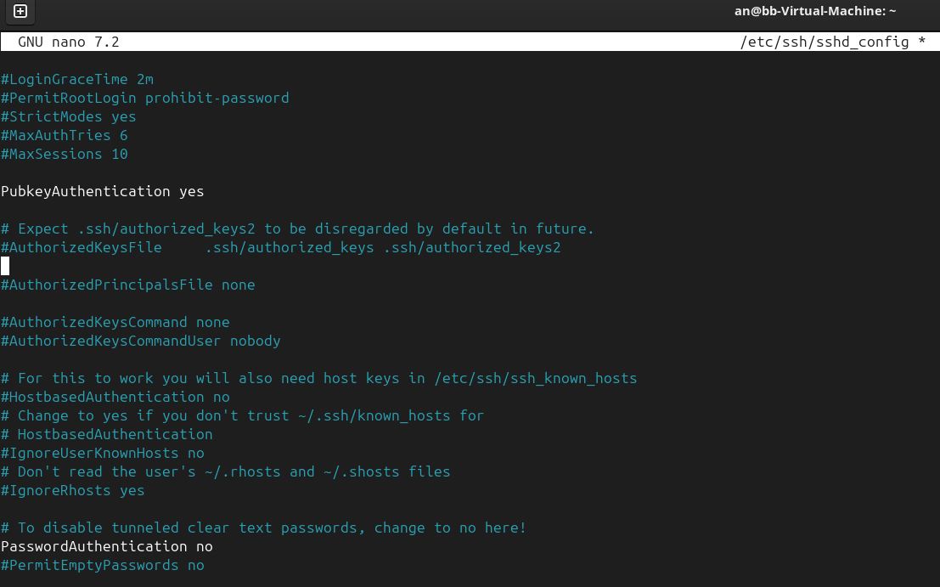

nano ~/.ssh/authorized_keys

ssh-rsa  ad@StudyVMRK

sudo systemctl restart sshd

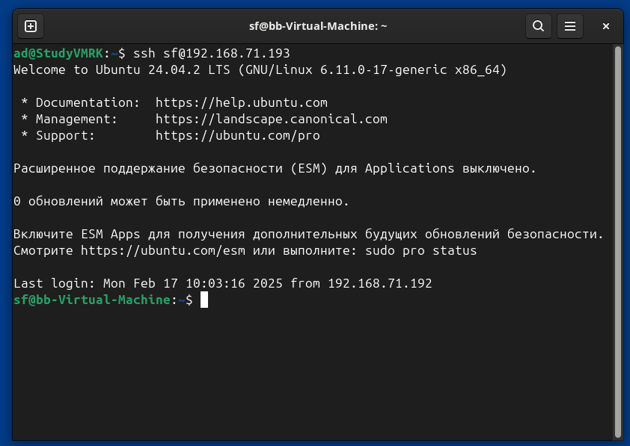

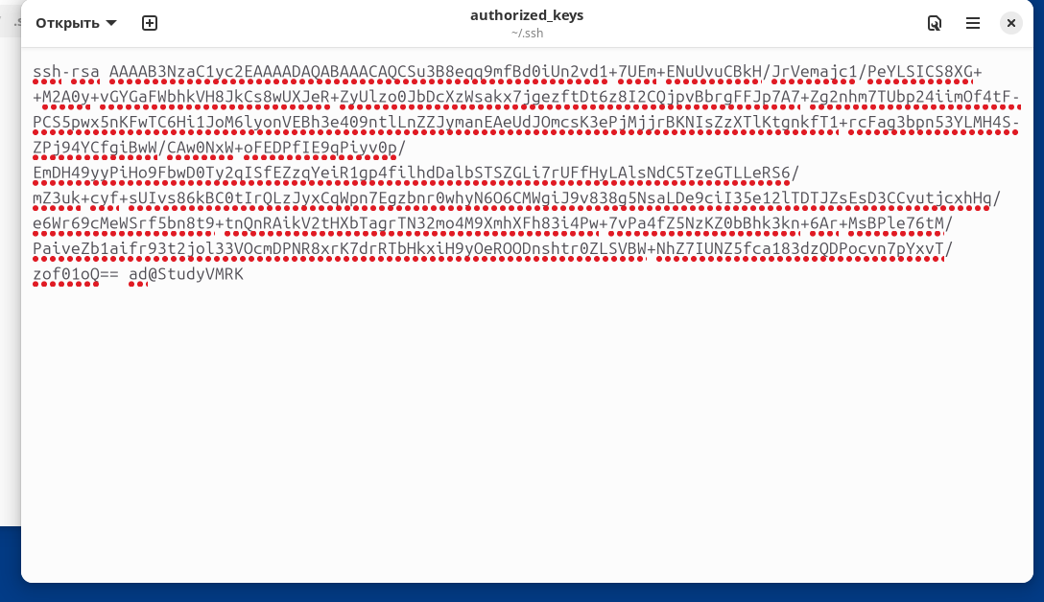

2) sudo useradd -m -s /bin/bash sf

sudo visudo

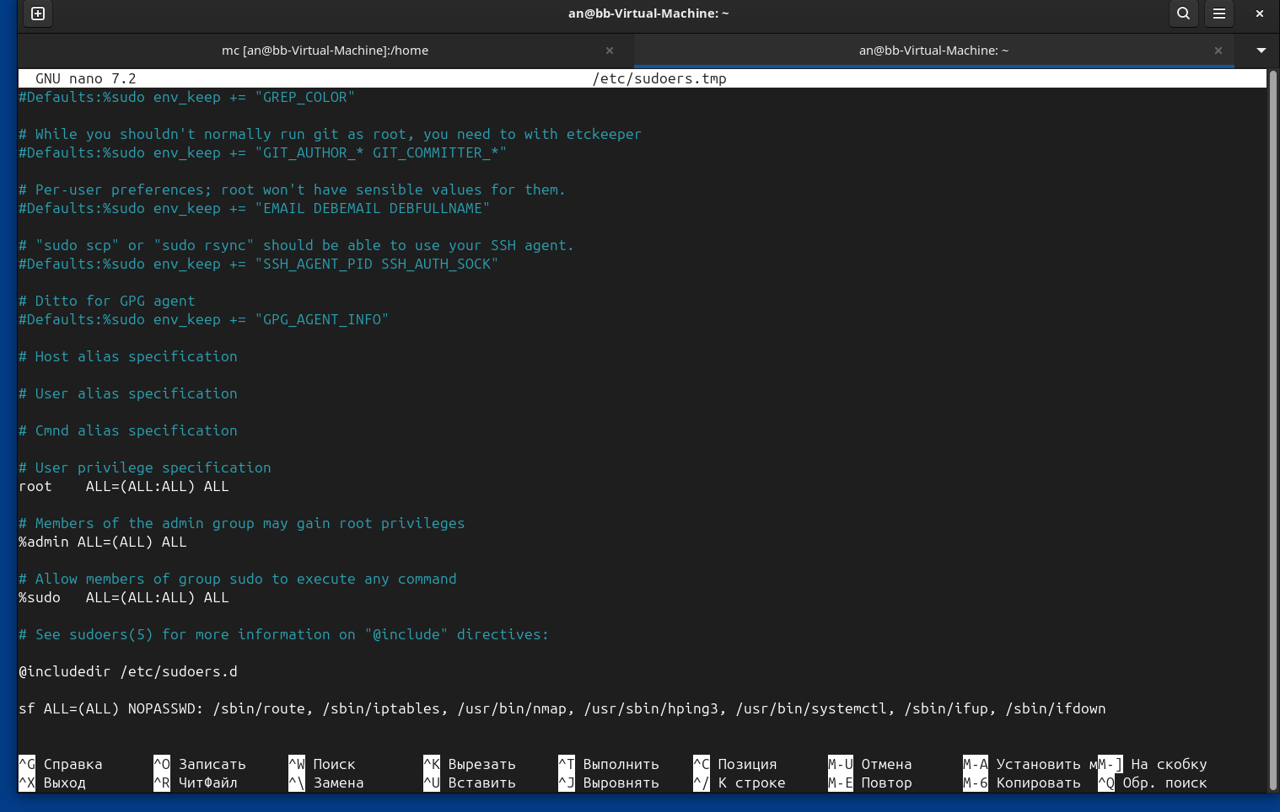

3) sudo nano /etc/pam.d/common-password

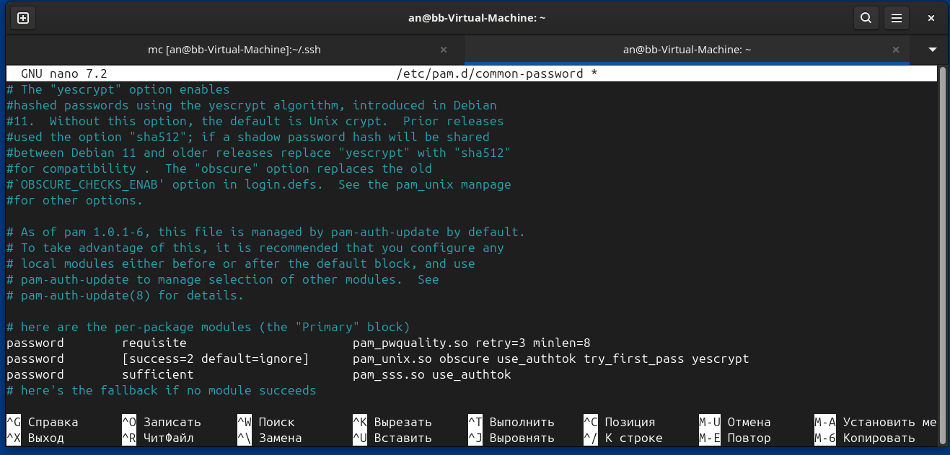

4) sudo apt install openjdk-17-jre

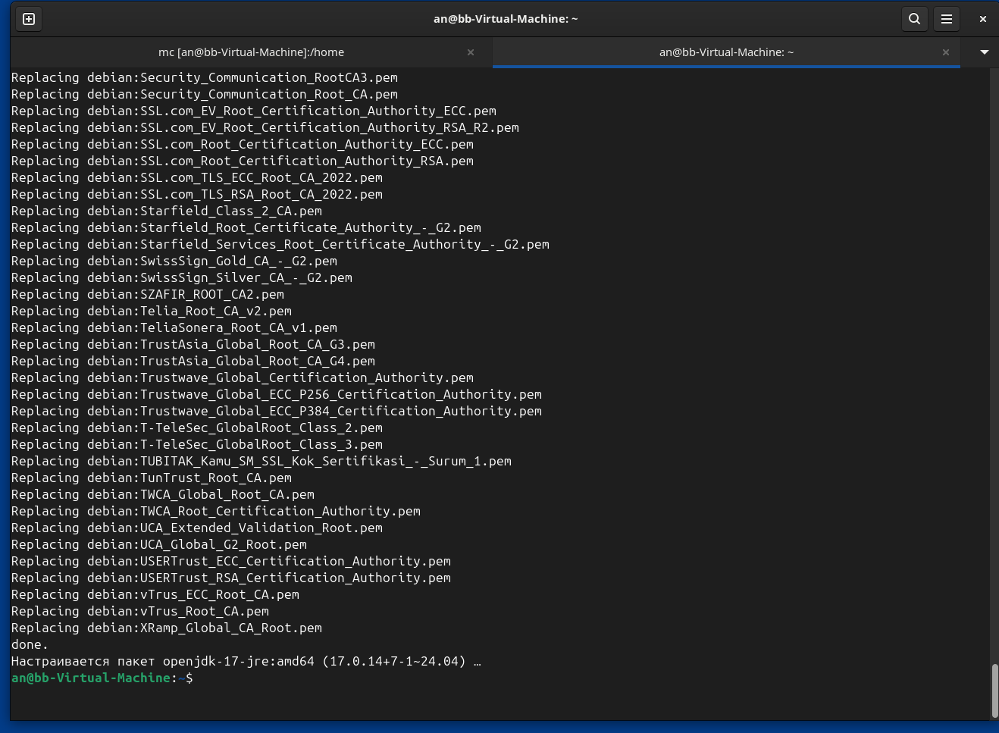

5) sudo apt install clamav clamav-daemon clamav-freshclam

sudo systemctl stop clamav-freshclam

sudo freshclam

sudo systemctl start clamav-freshclam

sudo apt install cron

sudo crontab -e

0 4 * * 1 /usr/bin/clamscan -r / --log /var/log/clamav/scan.log

0 0 1 * * /usr/bin/freshclam

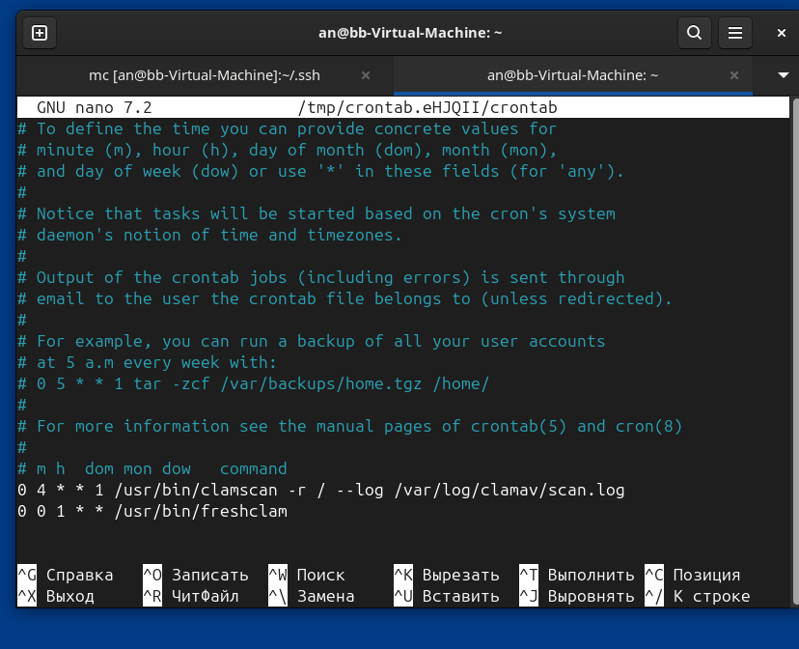

6) sudo iptables -L

sudo iptables -P INPUT DROP

sudo iptables -P OUTPUT DROP

sudo iptables -P FORWARD DROP

